Search for Harris Health System Jobs.
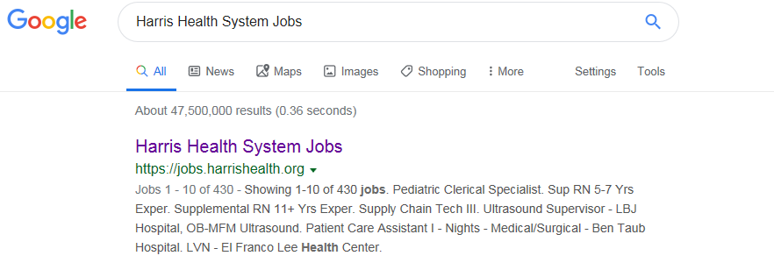

Click on All Jobs icon.

Type the Job number ID (149238) in the Keyword Search field and press Search button.
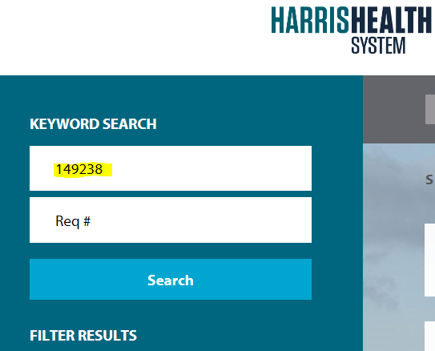

Supply Chain Inventory Analyst Job will appear. Click on the job and apply.
